Lab 1 Report
Noah Stern

1. Lab 1 was about configuring SSH on a client and server virtual machine to simulate being able to access a server anywhere in the world. This applies to the real world because you have to able to access your server remotely due to it not being viable to travel to your server every time there is an inconvenience.

2. The first step is install a server and client VM operating systems.

Configure the network adapter to be bridged to access all vms and hosts
Server name should be your last name with a -serv or -cli
Server only needs 1 or 2 GB of ram, client needs 4GB
Hard drives can be 80GB (dynamically allocated)

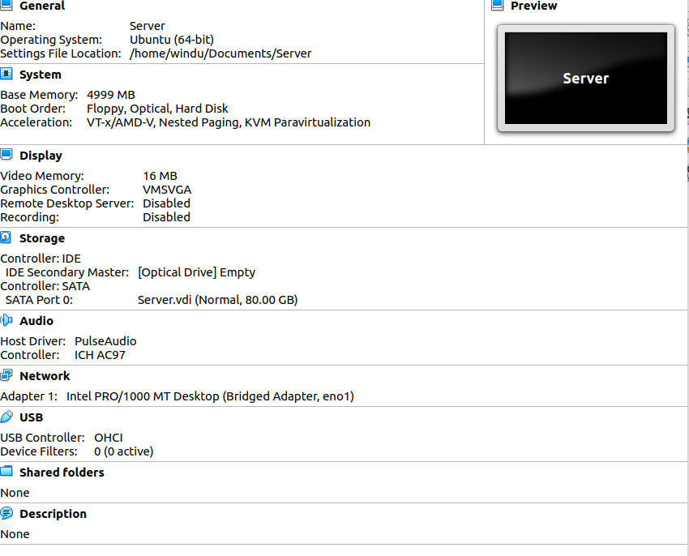
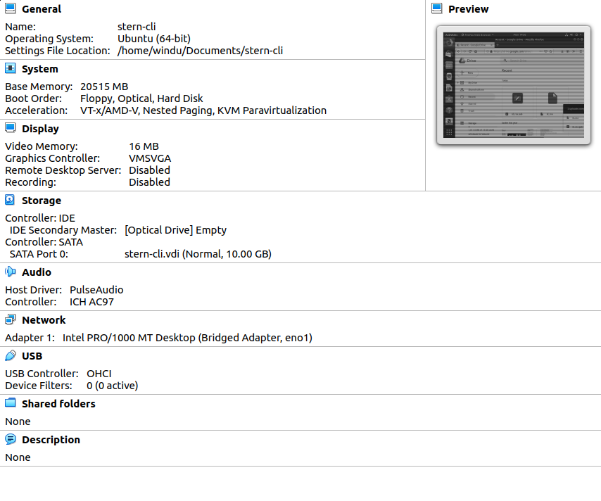
3. Install openssh-server on the linux server VM and install openssh-client on your linux client VM
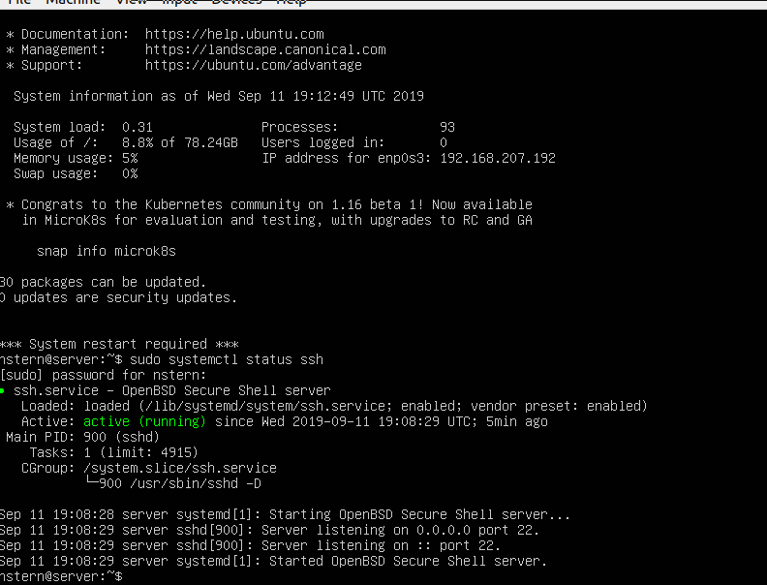
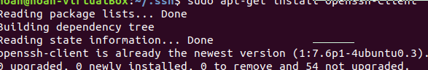
4. Generate an RSA key pair (a key size of 4096 bits should be secure for a long time) using ssh-keygen command line
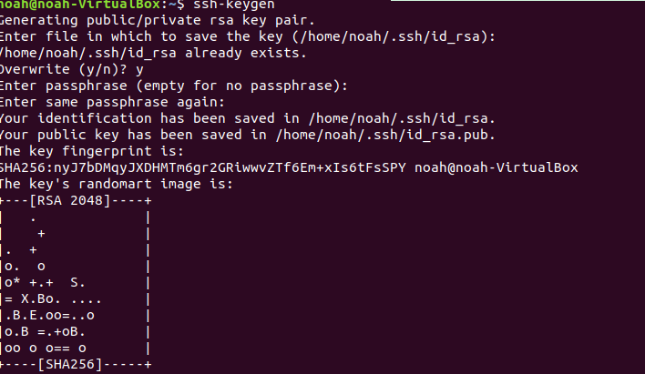
5. Configure both the keys on the respective servers (remember, public goes on the server and private on the client)
